5.1 The North Dorset Local Plan Part 1 was adopted in January 2016. The
following section is split by the objectives in the Local Plan Part 1:-
Objective 1 - Meeting the Challenge of Climate Change
Objective 2 - Conserving and Enhancing the Historic and Natural Environment
Objective 3 - Ensuring the Vitality of the Market Towns
Objective 4 - Supporting Sustainable Rural Communities
Objective 5 - Meeting the District’s Housing Needs
Objective 6 - Improving the Quality of Life

Objective 3 - Ensuring the Vitality of the Market Towns
5.15 The objective is to support the role and function of the market towns of
Blandford Forum (and Blandford St. Mary), Gillingham, Shaftesbury and Sturminster
Newton as the main service centres for the district by:
making them the main focus in the district for housing development, including
affordable housing;
enhancing their employment and training opportunities, particularly through the
provision of sufficient employment land, to meet the growing needs of the towns and
their hinterlands;
focusing an improved range of retail, cultural and leisure uses within the town
centres;
improving health, education and community services to meet the needs of the
towns and their rural hinterlands;
improving sustainable transport links and accessibility within the towns; between
the towns and the villages in their rural hinterlands; and, through improved linkages
with strategic transport networks;
securing the delivery of mixed use regeneration on previously developed land in
accessible locations;
ensuring that housing development is delivered in step with employment
opportunities, community facilities and infrastructure; and
taking account of the effects of any interaction between the towns themselves and
with the large towns and cities in neighbouring districts.
Employment
5.20 The other three towns have lower amounts of available employment land.
Shaftesbury has 6.97 hectares (24%), Sturminster has 4.49 hectares (15%) and
Blandford Forum has 3.46 hectares (12%).
Hectares
Blandford Forum 3.46
Gillingham 14.64
Shaftesbury 6.97
Sturminster Newton 4.49
Total 29.56

Amount of housing development in Blandford, Gillingham, Shaftesbury and
Sturminster
5.21 As the table below shows there were 85 net dwelling completions in the four
towns. Shaftesbury had the largest amount with 42%, followed by Blandford with
39%, Sturminster Newton with 12%, and Gillingham had the smallest amount with
70. Of the total completions in the towns 20% were for affordable homes. There were
17 affordable completions in Blandford.dwelling
n
Affordable
Houing
Completions
Net dwelling
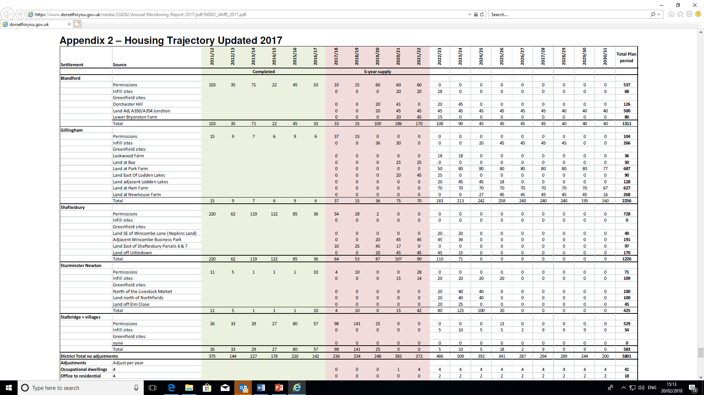as a t 1 April
2017
Affordable
Commitments
as at 1 April

